EXPERIMENT 08
Simple Single Page Web Application using React JS
Mrudul Bhagwat 16010125020 A1

Course Outcome: CO5 – Illustrate the concepts of various front-end web application developments, mockApi technologies frameworks using different web development tools.

Aim: To develop a simple Smart Irrigation Single Page Application using React JS, reusable components, JSX, a JavaScript array and React Router.

Objectives
- Understand the concept of a Single Page Application (SPA).
- Create multiple React components representing application views.
- Implement client-side navigation using React Router.
- Use JavaScript arrays and map() to generate UI elements.
- Reuse JSX and component concepts learned in Experiment 07.
Case Study: KisanSaathi Smart Irrigation. This experiment has Home, Farms and About views. Farm details are sample data for the lab.

Software Requirements
- Node.js and npm
- Visual Studio Code
- Google Chrome or another modern browser

Theory

Single Page Application (SPA)
A Single Page Application loads one HTML page. When we select an internal link, React changes the view without loading a new HTML document.

React Router
React Router connects a URL path to a component. This example uses BrowserRouter, Routes, Route and Link for navigation.

Link and HTML Navigation
- HTML commonly uses <a href="/about">About</a>.
- React Router uses <Link to="/about">About</Link> for client-side navigation.
- The goal is to switch application views without a full page navigation.

JavaScript map() in React
farms.map(farm => (
<p key={farm.id}>{farm.crop} - {farm.moisture}%</p>
));

Problem Statement
Develop a simple Smart Irrigation SPA with Home, Farms and About views. Use React Router for navigation. Display three sample farm records from a JavaScript array using map().

Tasks to be Given to Students
- Create a React application named react-irrigation-spa.
- Install react-router-dom.
- Create Home.jsx, Farms.jsx and About.jsx components.
- Create links for Home, Farms and About.
- Configure BrowserRouter, Routes and Route.
- Display a welcome message on Home.
- Display three farm records using a JavaScript array and map().
- Use a unique key for each generated item.
- Display application information on About.
- Apply simple CSS.
- Open each view and capture the output.

Procedure
1. Open a terminal and go to the practical folder.
2. Run: npm create vite@latest react-irrigation-spa -- --template react
3. Run: cd react-irrigation-spa, then npm install.
4. Run: npm install react-router-dom
5. Run: npm run dev and open the local address shown.
6. Create a pages folder inside src.
7. Create Home.jsx, Farms.jsx and About.jsx inside src/pages.
8. Write the three simple components and the farms array.
9. Import the components into App.jsx and add simple CSS.
10. Configure BrowserRouter, Routes, Route and Link.
11. Open /, /farms and /about using the links and capture screenshots.

Program Home.jsx
function Home() {
return (
<div>
<h2>Welcome to KisanSaathi</h2>
<p>This is a simple smart irrigation application.</p>
<p>Open Farms to see the sample soil moisture values.</p>
</div>
);
}
export default Home;

Program Farms.jsx
function Farms() {
const farms = [
{ id: 1, crop: "Sugarcane", moisture: 40 },
{ id: 2, crop: "Wheat", moisture: 65 },
{ id: 3, crop: "Tomato", moisture: 55 }
];
return (
<div>
<h2>Farm List</h2>
{farms.map(farm => (
<p key={farm.id}>
Farm {farm.id} - {farm.crop}: {farm.moisture}% moisture
</p>
))}
<p>These are sample values, not live sensor readings.</p>
</div>
);
}
export default Farms;

Program About.jsx
function About() {
return (
<div>
<h2>About</h2>
<p>KisanSaathi is a smart irrigation case study.</p>
<p>This React lab has Home, Farms and About views.</p>
<p>It uses React Router and a JavaScript array.</p>
</div>
);
}
export default About;

Program App.jsx
import { BrowserRouter, Routes, Route, Link } from "react-router-dom";
import Home from "./pages/Home";
import Farms from "./pages/Farms";
import About from "./pages/About";
import "./App.css";
function App() {
return (
<BrowserRouter>
<h1>KisanSaathi</h1>
<p>Smart Irrigation Single Page Application</p>
<nav>
<Link to="/">Home</Link> |{" "}
<Link to="/farms">Farms</Link> |{" "}
<Link to="/about">About</Link>
</nav>
<Routes>
<Route path="/" element={<Home />} />
<Route path="/farms" element={<Farms />} />
<Route path="/about" element={<About />} />
</Routes>
</BrowserRouter>
);
}
export default App;

Program App.css
body {
font-family: Arial, sans-serif;
max-width: 650px;
margin: 30px auto;
padding: 0 20px;
}
h1 { color: darkgreen; }
nav { margin: 20px 0; }
a { color: darkgreen; }

Program main.jsx
import React from "react";
import ReactDOM from "react-dom/client";
import App from "./App";
ReactDOM.createRoot(document.getElementById("root")).render(
<React.StrictMode>
<App />
</React.StrictMode>
);

Output
The local app displays Home, Farms and About. The Farms view shows Sugarcane at 40%, Wheat at 65% and Tomato at 55% moisture. These screenshots were captured from http://127.0.0.1:5174/ and its /farms and /about routes.
Home view and Farms view
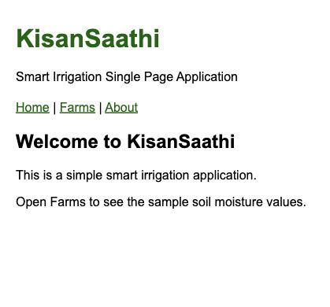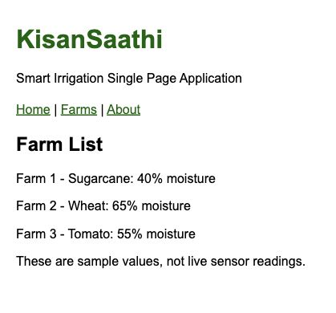
About view
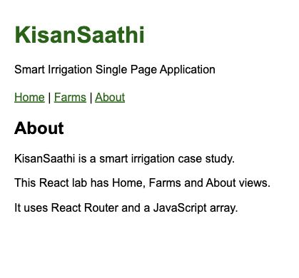

Result
I created a simple Single Page Application for the Smart Irrigation case study. I used React Router to move between three views and map() to display farm records. I learned how components can be used as pages. The moisture values are fixed sample data. Live sensors, weather data and pump control are not included.

Viva Questions
- Why is React Router used?
Answer: React Router lets us move between views such as Home, Farms and About without loading a new HTML document.
- What are BrowserRouter, Routes and Route?
Answer: BrowserRouter enables routing using the browser URL. Routes holds the route list. Route connects one path to one component.
- What is the difference between Link and an HTML anchor?
Answer: Link changes the React view without a full page reload. An HTML anchor normally asks the browser to navigate to its target document.
- Why is key used in React lists?
Answer: A key gives each list item a stable identity. React uses it to match items when a list changes. Here, farm.id is the key.
- How does map() help in React?
Answer: map() runs a function for every item in an array and returns a new array. Here, it creates one paragraph for each farm.
- How does Experiment 08 extend Experiment 07?
Answer: Experiment 07 introduced components, props and state. Experiment 08 uses components for three views and adds React Router and a list made with map().

